**“Wine & Equipment Education Tour” Co-sponsored by BSE and AHFNY Date: July 20, 2023, 5 CEU requested for RDN & CDM**

**Location: Osprey's Dominion Winery, 44075 Main Rd, Peconic, NY 11958**

**631-765-6188**

**Bus: Leaving 9AM sharp from SA Commissary parking & returning 4PM from Winery**

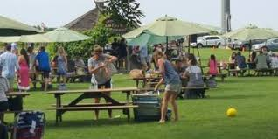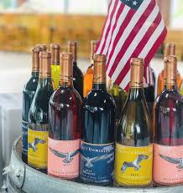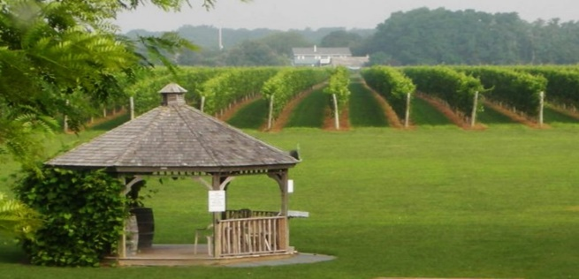**Price including: 4 wine tasting, discount to wine store, lunch, and transportation:**

**$40 for operator member & business partner**

**$100 for non-member (including 2023 operator membership) & guest of member**

**$100 for vendor**

**Registration: Not refundable. Must receive by 7/17/2023**

**Name: ______________________ Cell: _______________________**

**Member________ Non-member___________**

**Pay with PayPal: (**[**https://ahfny.org/events.aspx**](https://ahfny.org/events.aspx)**) or**

**Write check to: AHFNY then mail to: Mimi Wang, 225 Cherry Street, Apt. 52D, NY, NY 10002**

**Questions: 347-675-5560,** [**mimi.wang@va.gov**](mailto:mimi.wang@va.gov)